**Milestone II submission**

**Team: The Next Team**

**Proposed Level of Achievement:** Gemini

**Developments in the game:**

* Finishing all the game logic for single player mode (including moving, collecting coins, items effects)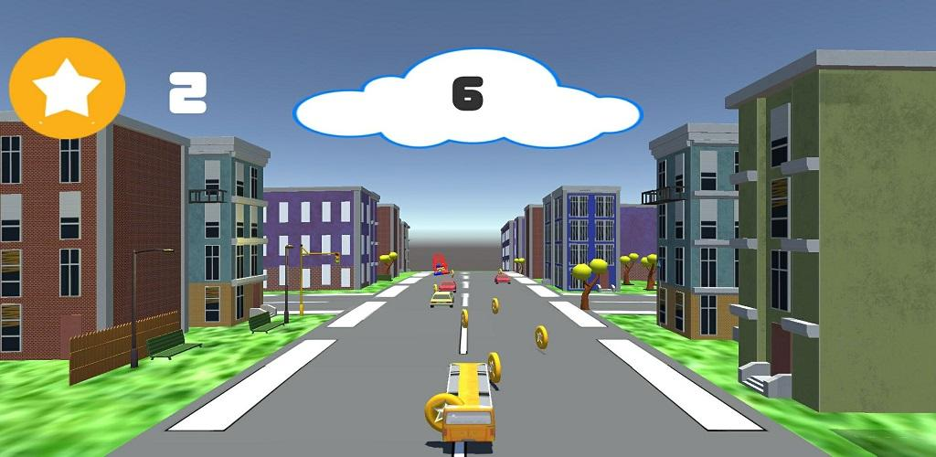
* Storing and showing best scores locally, storing coins for future shop developments
* Adding advertisements for option to revive the games
* Making a share system for sharing through social media platform (Facebook)

**Back-end Progress:**

* Making a database to store user’s scores, achievements and leaderboard

**Problems encountered:**

* Login authentication in google receives bug and still requires further dealing

**Future plan:**

* Fixing the login problems in order to update the leaderboard and achievements
* Creating shop for users to customize their bus